**Software to Install on Raspberry Pi**

Before attempting to install any software you should run

sudo apt-get update

in order to update the package lists for upgrades for packages that need upgrading, as well as new packages that have just come to the repositories.

1. TuxMath

TuxMath is where mathematics meets the arcade. In this shooting game, asteroids threaten friendly penguin Tux. His ammunition? Mental arithmetic! The flying moonrocks are actually space division, multiplication and subtraction, and by finding the answer, you destroy them, and saving the penguin igloos from the devastating impact. TuxMath is an open source, free game whose difficulty is appropriate for students from elementary to high school, in other words, 7 to 13 years. It offers dozens of missions that require calculations that get more and more complicated, ending up with some really tricky stuff, like the division of negative numbers.

TuxMath also offers a second, more advanced mode, where the asteroids are fractions you destroy by finding their common denominator.

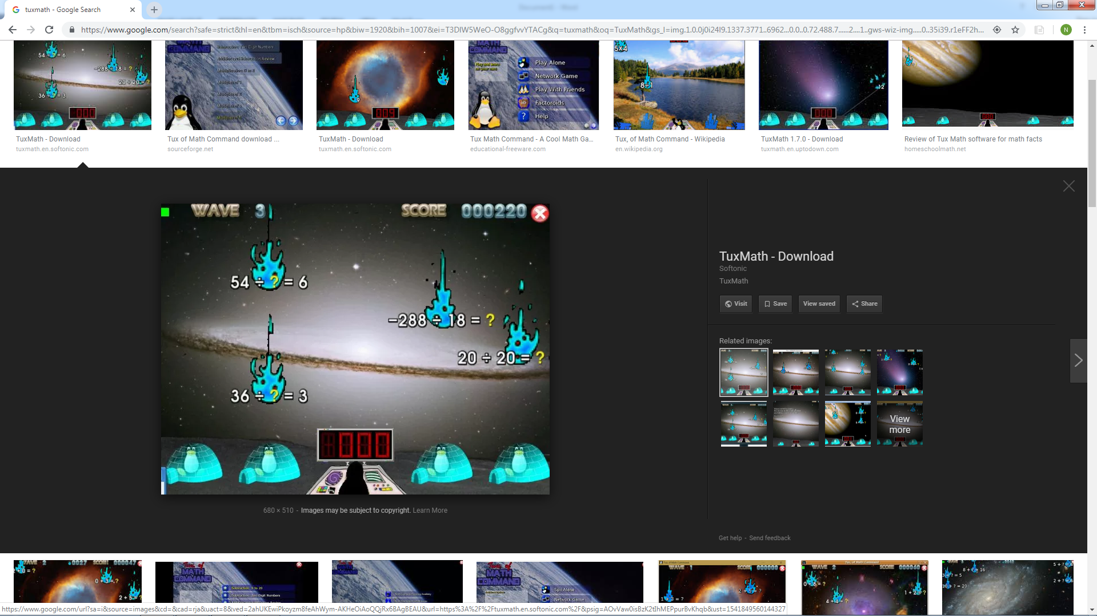

Installation: sudo apt-get install tuxmath

1. TuxType

Tux Typing is a free and open source typing tutor created especially for children. It features several different types of game play, at a variety of difficulty levels. It is designed to be fun and to improve words per minute speed of typists.

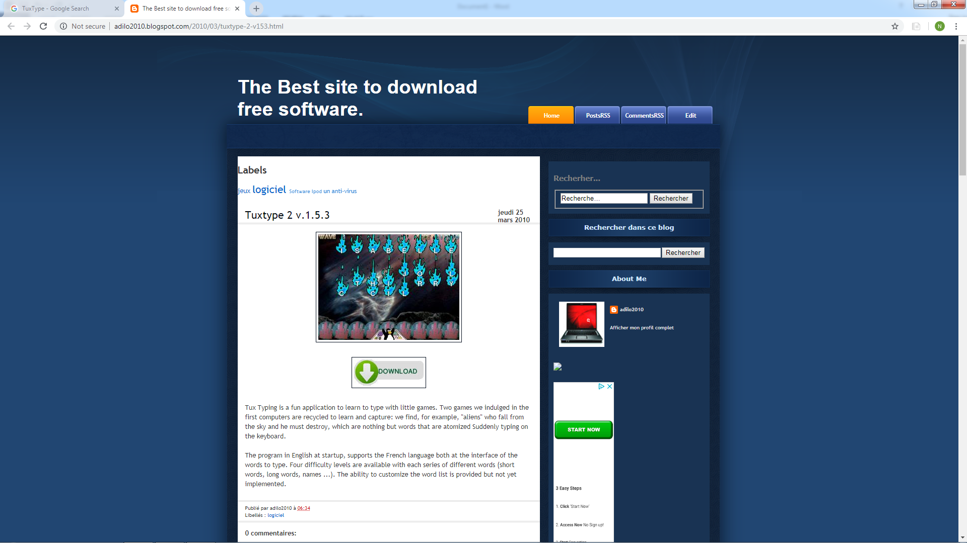

Installation: sudo apt-get install tuxtype

1. TuxPaint

Tux Paint is a free, [award-winning](http://tuxpaint.org/reviews/) drawing program for children ages 3 to 12 (for example, preschool and K-6). Tux Paint is used in schools around the world as a computer literacy drawing activity. It combines an easy-to-use interface, fun sound effects, and an encouraging cartoon mascot who guides children as they use the program.

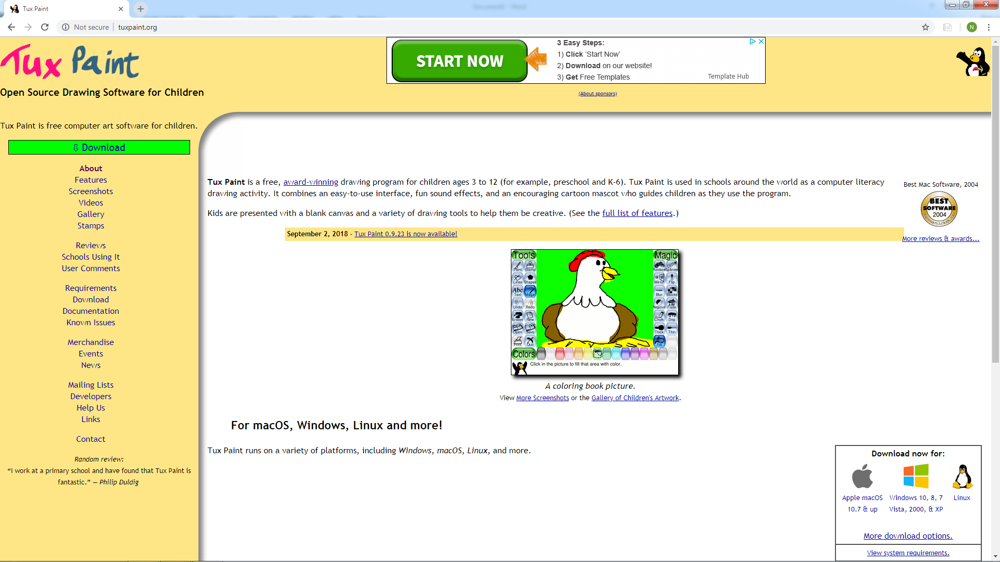

Installation: sudo apt-get install tuxpaint

1. GCompris

GCompris is a high quality educational software suite comprising of numerous activities for children aged 2 to 10. Some of the activities are game oriented, but nonetheless still educational.

Features

* computer discovery: keyboard, mouse, different mouse gestures
* arithmetic: table memory, enumeration, double entry table, mirror image
* games: chess, memory, connect 4, oware, sudoku
* geography: place the country on the map
* reading: reading practice
* science: the canal lock, the water cycle, the submarine, electric simulation
* other: learn to tell time, puzzle of famous paintings, vector drawing, cartoon making

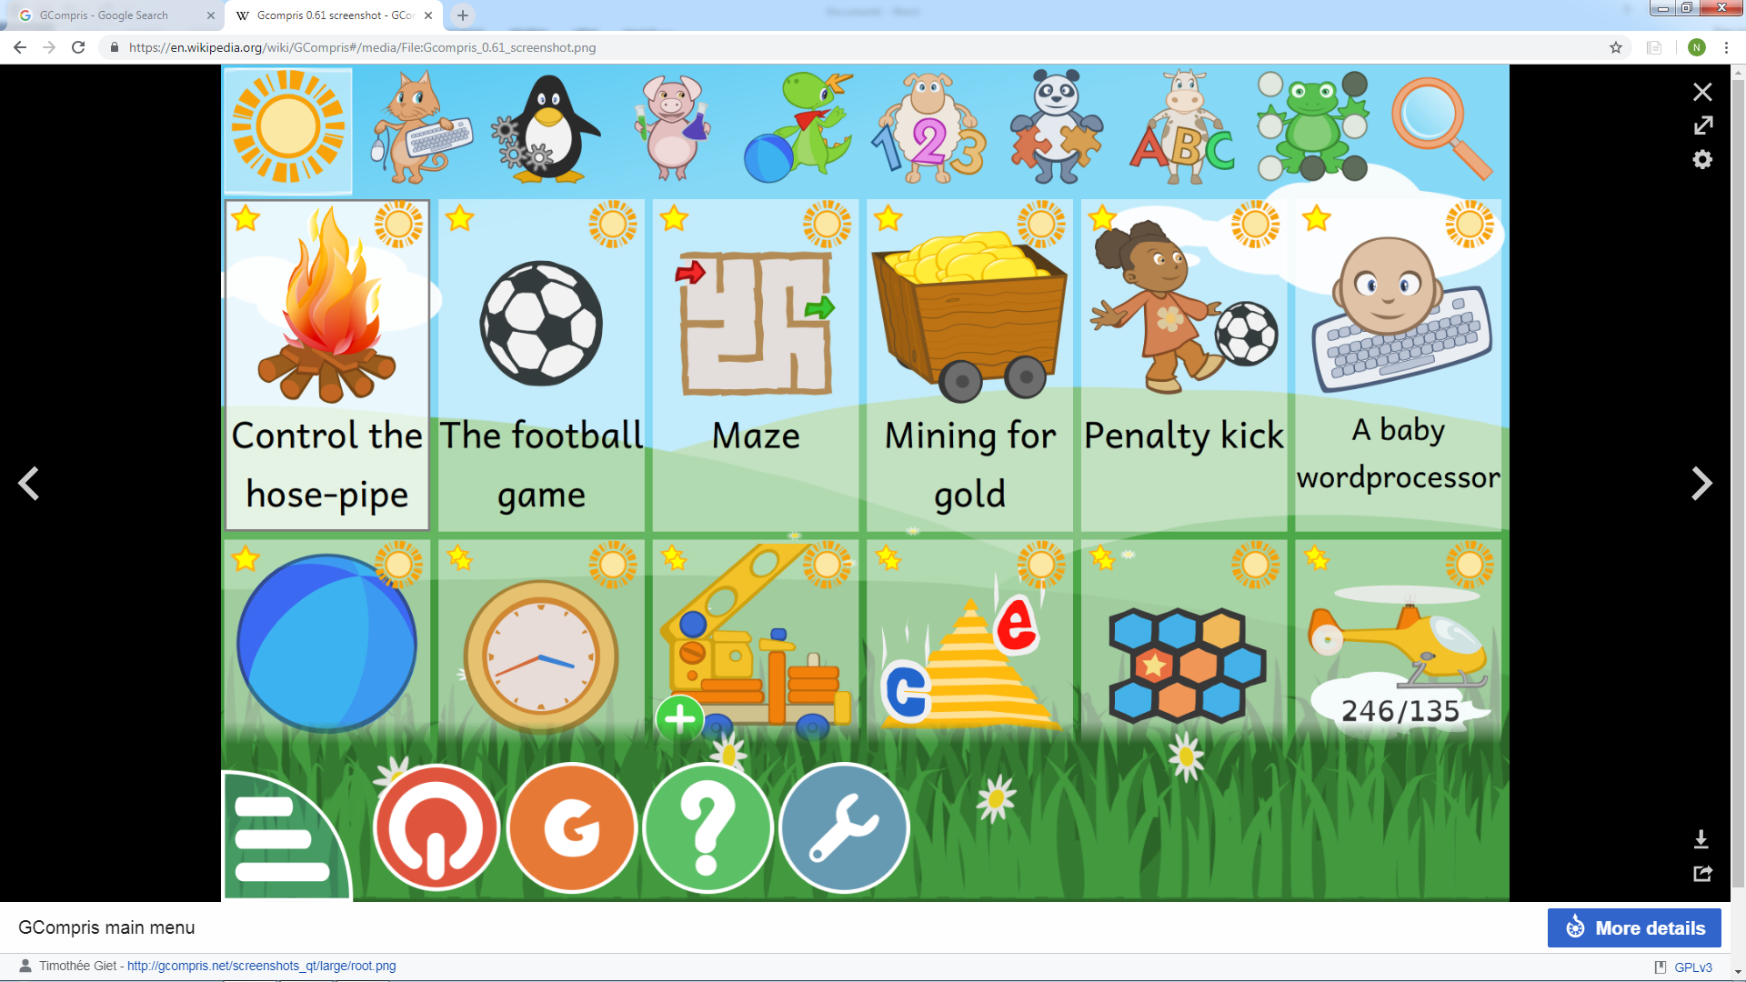

Installation: sudo apt-get install gcompris

1. GIMP

GIMP is a free and open-source raster graphics editor used for image retouching and editing, free-form drawing, converting between different image formats, and more specialized tasks.

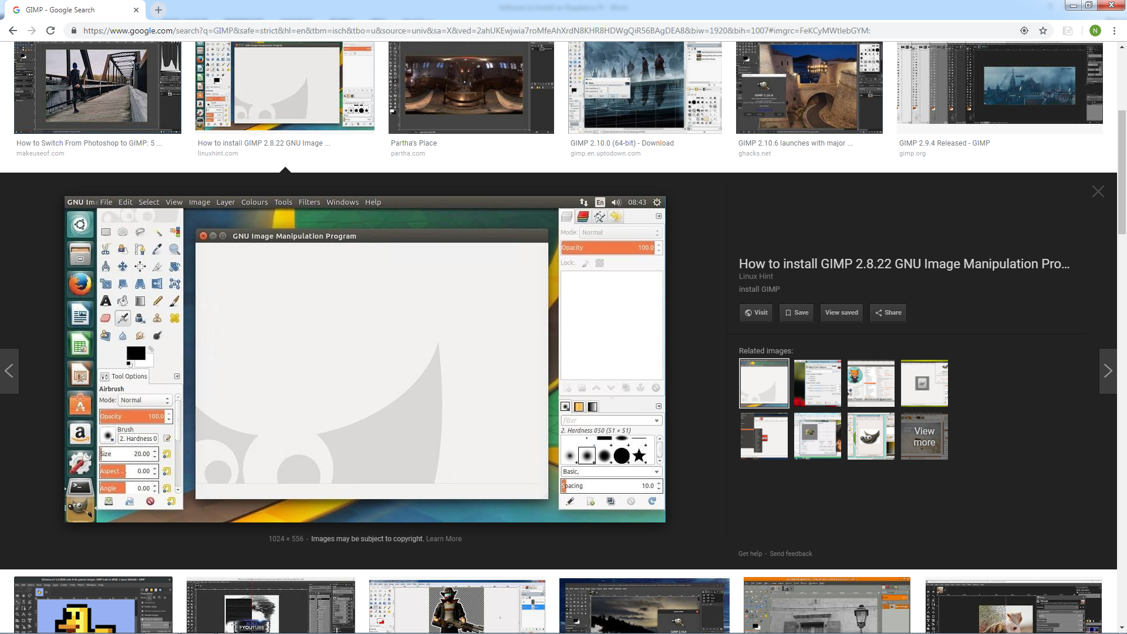

Installation: sudo apt-get install gimp

1. GBrainy

Gbrainy is a brain teaser game for GNOME designed for use in education. Specifically, it contains the following:

* Logic puzzles - games designed to challenge reasoning and thinking skills
* Mental calculation - games based on arithmetical operations designed to improve mental calculation skills
* Memory trainers - games designed to challenge short term memory
* Verbal analogies - games that challenge your verbal aptitude

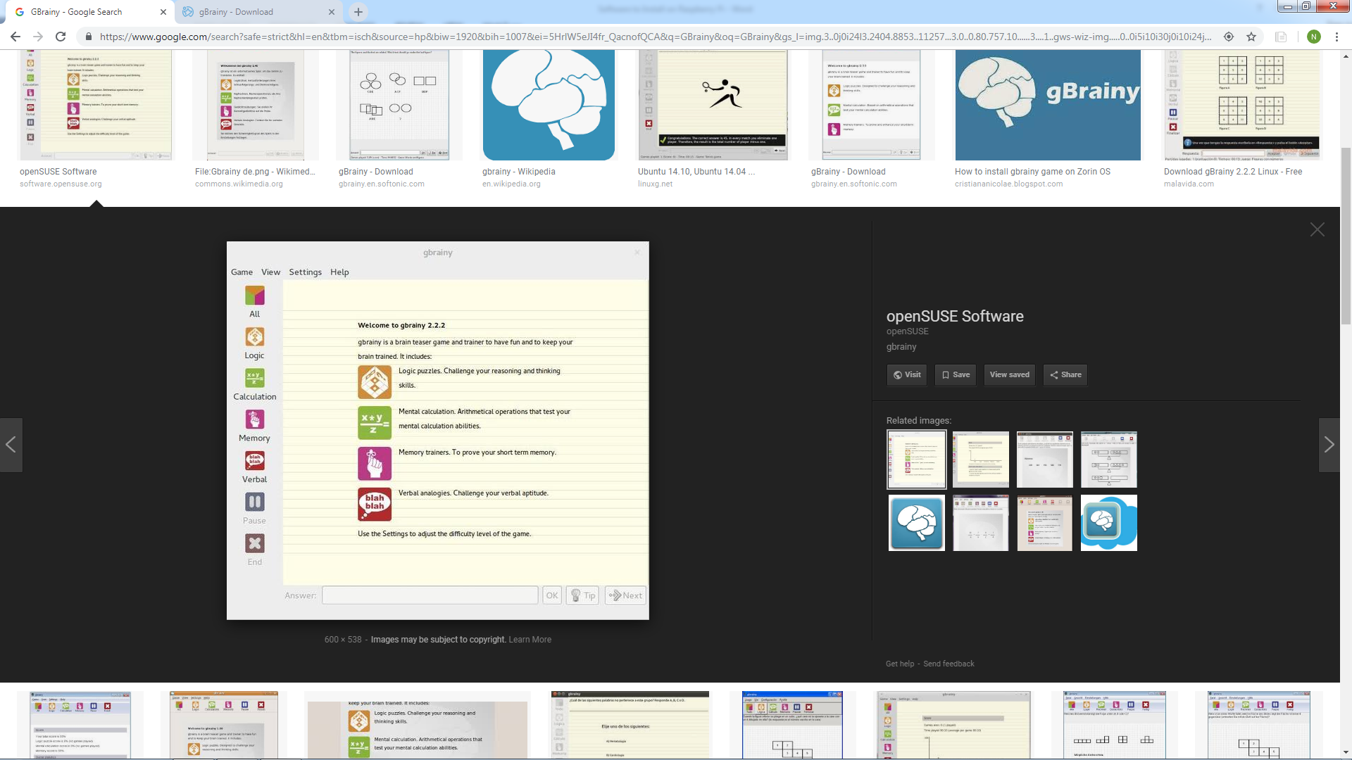

Installation: sudo apt-get install gbrainy

1. Inkscape

Inkscape is a free and open-source vector graphics editor; it can be used to create or edit vector graphics such as illustrations, diagrams, line arts, charts, logos and complex paintings. Inkscape's primary vector graphics format is Scalable Vector Graphics; however, many other formats can be imported and exported.

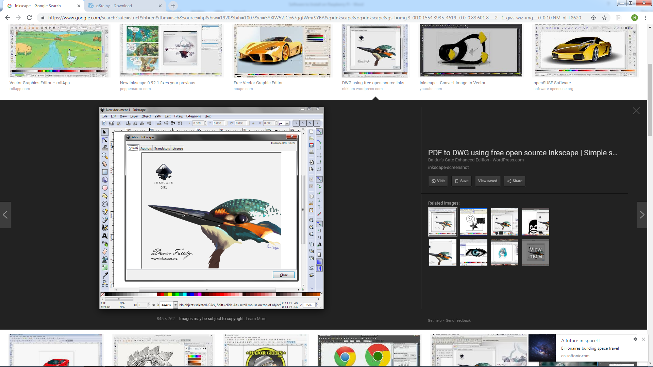

Installation: sudo apt-get install inkscape

1. Arduino IDE

The open-source Arduino Software (IDE) makes it easy to write code and upload it to the board. It runs on Windows, Mac OS X, and Linux. The environment is written in Java and based on Processing and other open-source software.  This software can be used with any Arduino board.

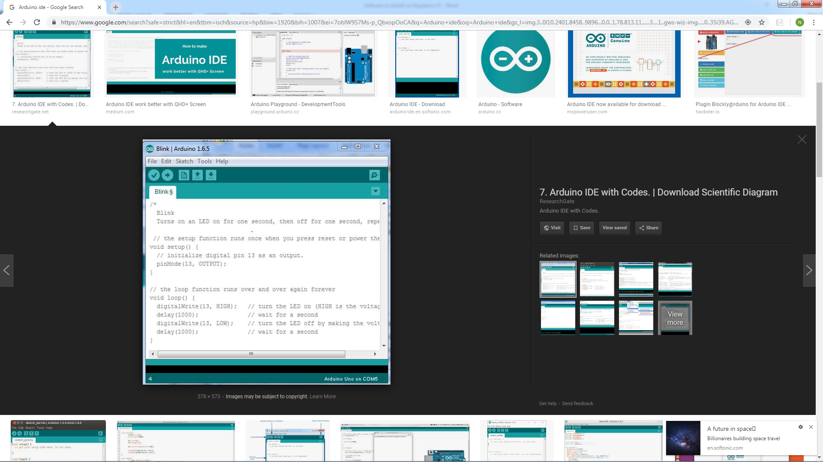

Installation: sudo apt-get install arduino

1. Processing

Processing is an open-source graphical library and integrated development environment / playground built for the electronic arts, new media art, and visual design communities with the purpose of teaching non-programmers the fundamentals of computer programming in a visual context.

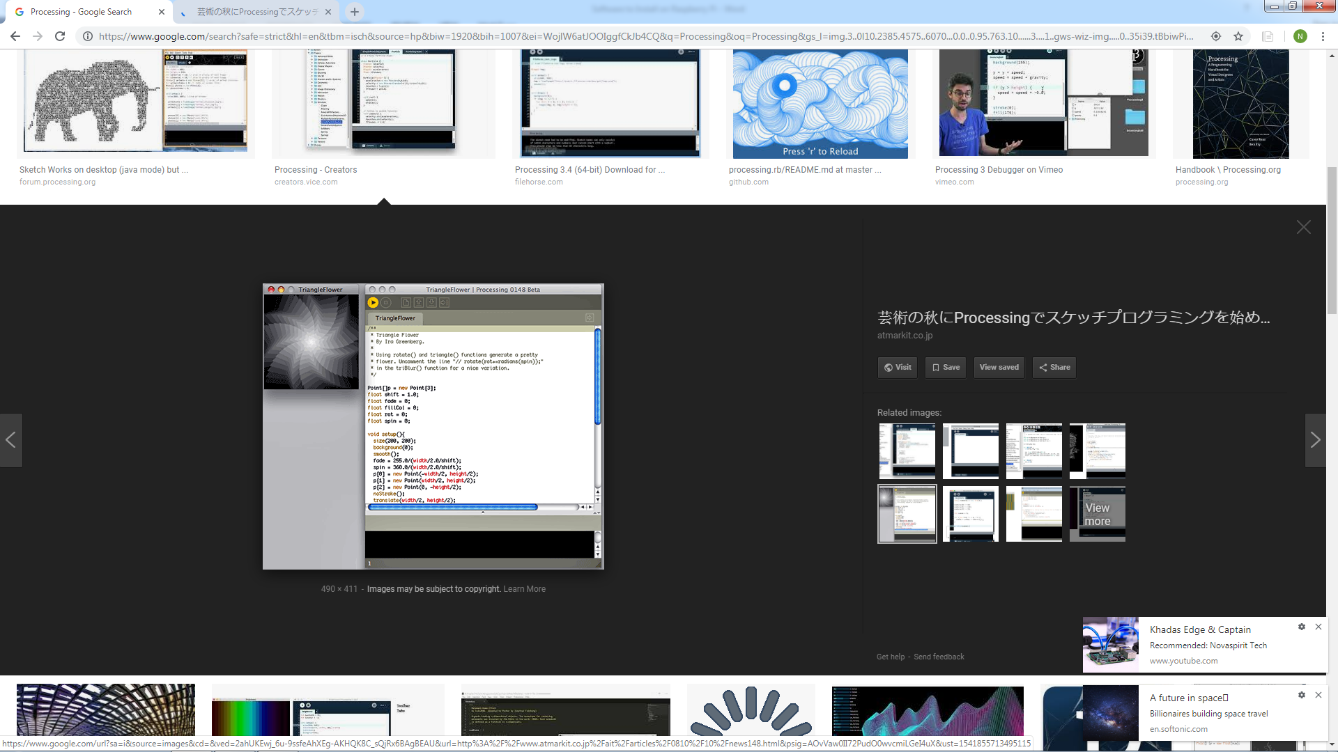

Installation: curl https://processing.org/download/install-arm.sh | sudo sh

1. VLC

VLC media player is a free and open-source, portable, cross-platform media player and streaming media server developed by the VideoLAN project. VLC is available for desktop operating systems and mobile platforms.

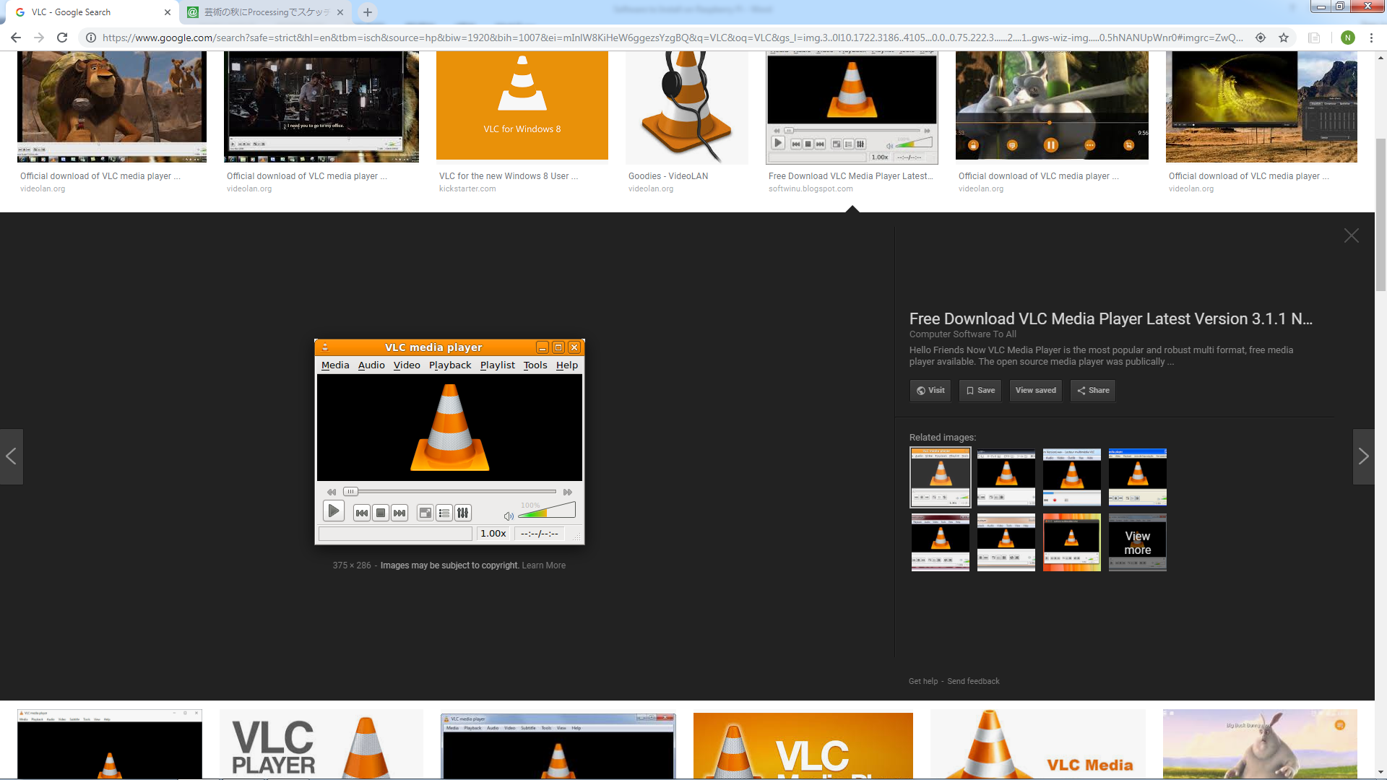

Installation: sudo apt-get install vlc

1. Audacity

Audacity is an easy-to-use, multi-track audio editor and recorder for Windows, Mac OS X, GNU/Linux and other operating systems. Developed by a group of volunteers as open source.

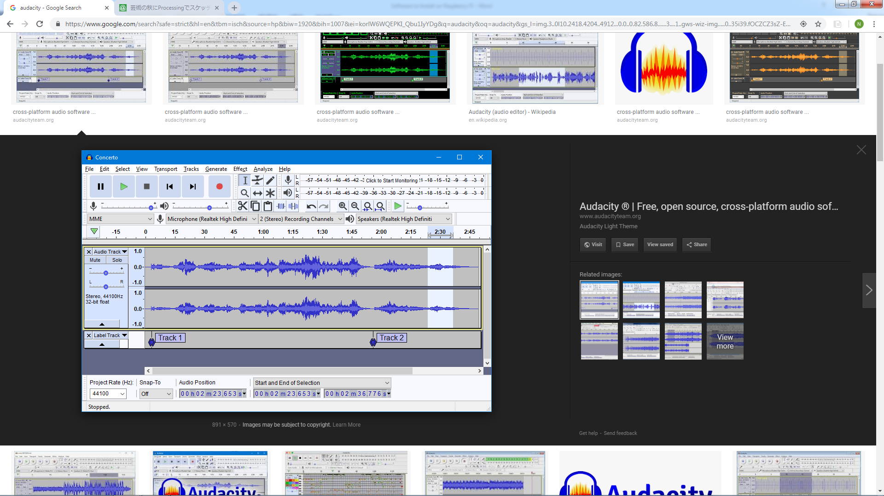

Installation: sudo apt-get install audacity